Editors - Text Editor
Text Editor 1

Text Editor

Bforartists has a Text Editor among its windows types, accessible via the Window type menu. It is mainly used to write Python scripts, and so the functionality orients towards this useage.
The newly opened Text window has a very simple toolbar (Text Toolbar).
Text Toolbar.
From left to right there are the standard Window type selection button and the window menus. Then there is the Text ID Block browse button followed by the New button for creating new Text files. Once you click it, you will find that the Toolbar has changed.. for good!
Text Toolbar with a file open
Now you find a textbox to change name of your text file, followed by + button to create new files. To remove the text block, click the X button.
The following three buttons toggle display of line numbers, word-wrap text and syntax highlighting respectively.
Typing on the keyboard produces text in the text buffer. As usual, pressing dragging and releasing LMB selects text.
To delete a text buffer just press the X button next to the buffer’s name, just as you do for materials, etc.
It is worth noticing that Bforartists comes with a fully functional Python interpreter built in, and with a lots of Bforartists-specific modules, as described in the API references.
The Text Editor has now also some dedicated Python scripts, which add some useful writing tools, like a class/function/variable browser, completion... You can access them through the File / Template menu entry.
Some functionality can also be found in the tool shelf at the left.
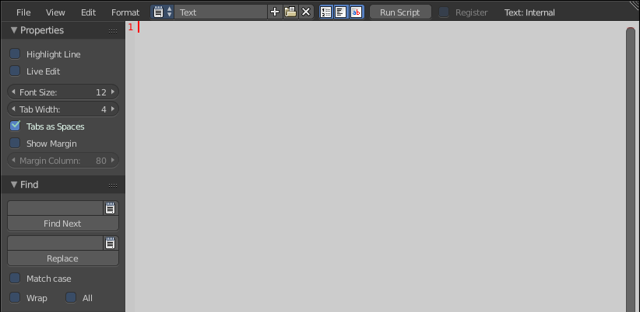
Tip
Usages for the Text window
The text window is handy also when you want to share your .blend files with others. A Text window can be used to write in a README text explaining the contents of your blend file. Be sure to keep it visible when saving!

